**Lab Exercise 11**

**Setting up Slack Channel for Configuring Build Notifications**

**Objective:** To set up Slack channel for configuring build notifications for receiving updates about the build process

**Tools required:** Jenkins

**Prerequisites:** Slack account

Steps to be followed:

1. Log in to the Jenkins CI tool and create a freestyle job
2. Set up Slack channel
3. Configure Slack in Jenkins

**Step 1: Log in to the Jenkins CI tool and create a freestyle job**

1. Open the browser, go to the Jenkins **Dashboard** by typing **localhost:8080** in your browser, provide the credentials, and click the **Sign in** button

|  |
| --- |
| **Note:** The credentials for accessing Jenkins in the lab are Username: **admin** and Password: **admin.** |

1. Click on the **New Item** option as shown in the screenshot below:

1. Enter a desired name for the project, select **Freestyle project**, and then click on **OK** as shown in the screenshot below:

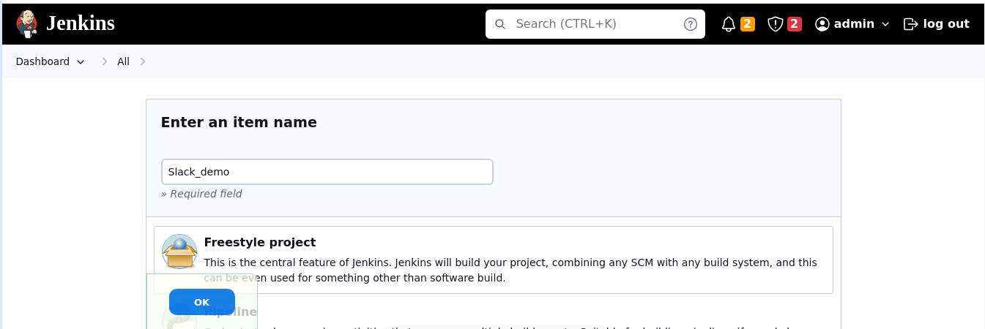

1. Click on **Save** button as shown in the screenshot below:

1. Click on **Manage Jenkins** as shown in the screenshot below:

1. Click on **Plugins** as shown in the screenshot below:

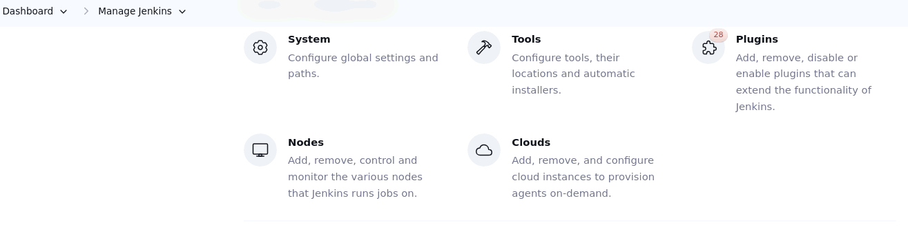

1. Click on **Installed plugins** to verify whether the **Slack Notification Plugin** has been installed

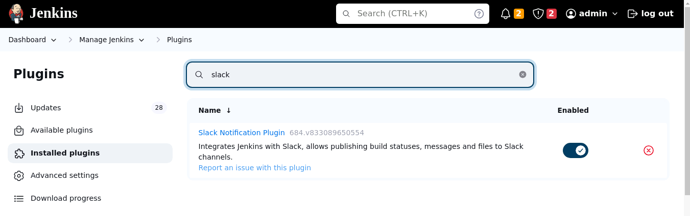

|  |
| --- |
| **Note:** **Slack Notification Plugin** is already installed in your practice lab environment. If not, click on **Available plugins** and search for **Slack Notification Plugin** and install it. |

**Step 2: Set up Slack channel**

1. Open the browser, go to Slack, enter a desired name of your company or team, and   
    then click on **Next** as shown in the screenshot below:

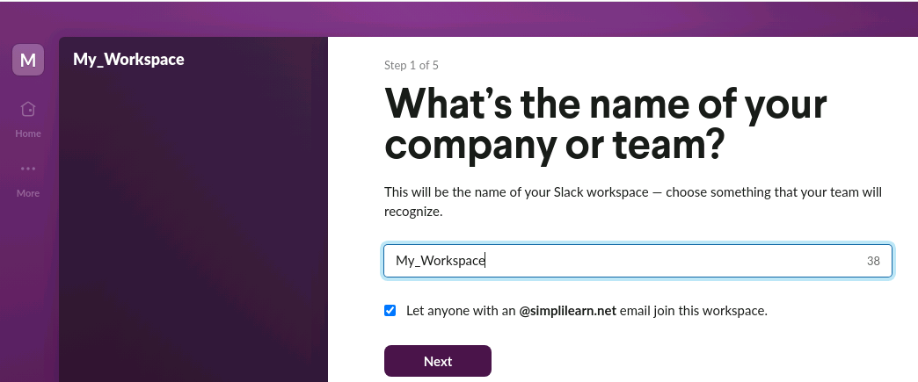

|  |
| --- |
| **Note:** Ensure that you create a personal Slack account using your personal email address  to proceed |

1. Enter a desired name for your profile and then click on **Next** as shown in the screenshot below:

1. Click on **Skip this step** as shown in the screenshot below:

|  |
| --- |
| **Note:** You can skip this step, as it is not necessary to add any coworker email in here. |

1. Enter a desired channel name and then click on **Next** as shown in the screenshot below:

1. Click on **Start with Free** as shown in the screenshot below:

1. Click on the channel name that you have created as shown in the screenshot below:

1. Click on **Integrations** as shown in the screenshot below:

1. Click on **Add an App** as shown in the screenshot below:

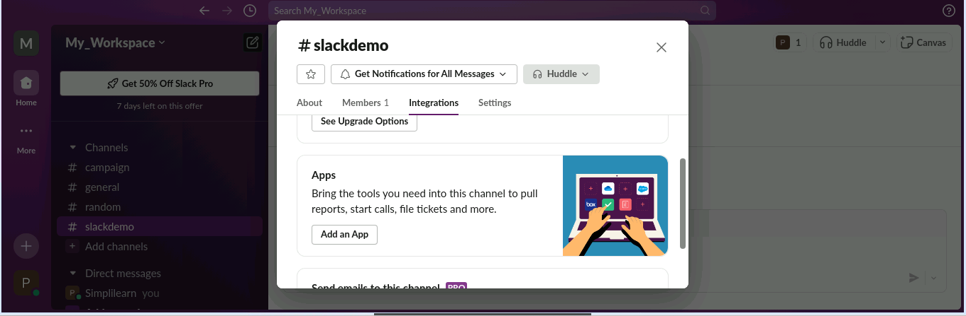

1. Search for Jenkins and then click on **Install** as shown in the screenshot below:

1. Click on **Add to Slack** as shown in the screenshot below

1. Click on the **Choose a channel…** drop-down, select the channel that you have created,   
    and then click on **Add Jenkins CI integration** as shown in the screenshot below:

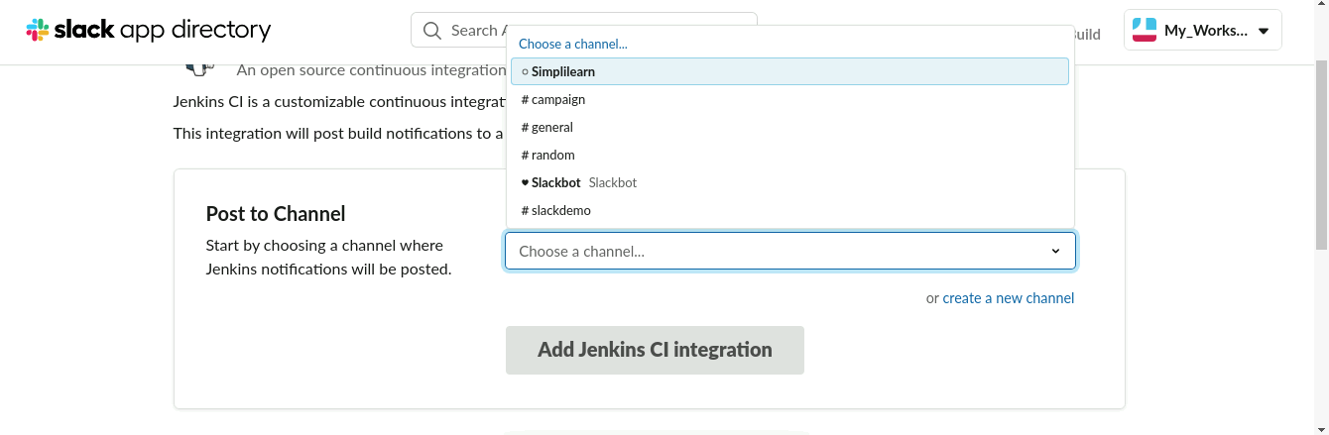

1. Scroll down to **Step 3** in the notifier page; you will see subdomain name and secret text  
    credential as shown in the screenshot below:

|  |
| --- |
| **Note:** Note down the subdomain and token credential for further steps |

**Step 3: Configure Slack in Jenkins**

1. Navigate into your Jenkins **Dashboard** and click on the Freestyle job that you have created as shown in the screenshot below:  
     
   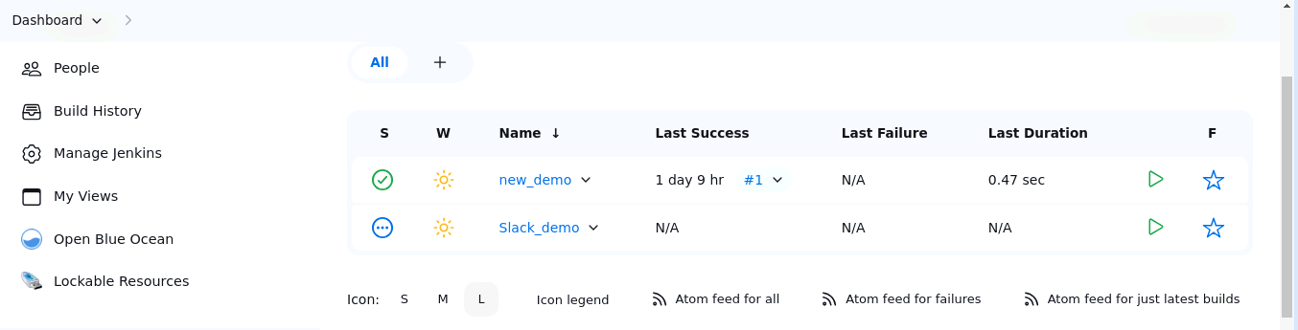

1. Click on **Configure** as shown in the screenshot below:  
     
   A screenshot of a computer

   Description automatically generated
2. Click on **Post-build Actions** as shown in the screenshot below:  
     
   A screenshot of a computer

   Description automatically generated
3. Click on **Add post-build action** drop-down and select **Slack Notifications** as shown in the screenshot below:  
     
   A screenshot of a computer

   Description automatically generated
4. Select the desired notifications and then click on **Save** as shown in the screenshot below:  
     
   A screenshot of a computer

   Description automatically generated
5. Click on **Manage Jenkins** as shown in the screenshot below:

1. Click on **System** as shown in the screenshot below:

1. Scroll down to the bottom of the screen; under the **Slack** section, enter your workspace name, which is the Subdomain name, as shown in the screenshot below:  
     
   A screenshot of a computer

   Description automatically generated

|  |
| --- |
| **Note:** Refer to the step 2.12 for Subdomain name |

1. Click on **Add** as shown in the screenshot below:

1. Click on **Jenkins** as shown in the screenshot below:

1. Choose **Secret text** under **Kind** section as shown in the screenshot below:

1. Enter the token credential under **Secret** section as shown in the screenshot below:  
     
   A screenshot of a computer

   Description automatically generated

|  |
| --- |
| **Note**: Refer to step 2.12 for token |

1. Enter a desired name for **Description** and then click on **Add** as shown in the screenshot   
   below:   
     
   A screenshot of a computer

   Description automatically generated
2. Choose the credential name from the list that you have created as shown in the screenshot below:

1. Enter the name of the channel that you have created and then click on **Apply** as shown in the screenshot below:  
    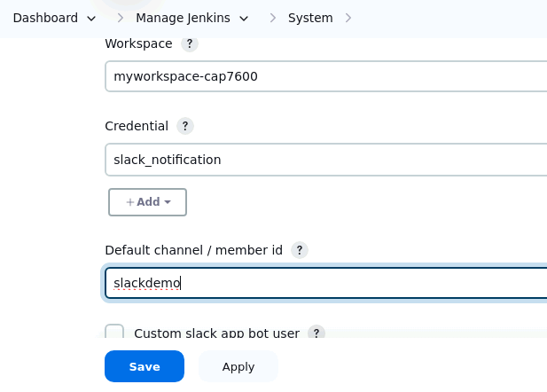
2. Click on **Test Connection** to verify that the status shows **Success**,and then click on **Save** as shown in the screenshot below:   
     
   A screenshot of a computer

   Description automatically generated
3. Navigate to the slack channel that you have created and check the notification of Jenkins as shown in the screenshot below:  
     
   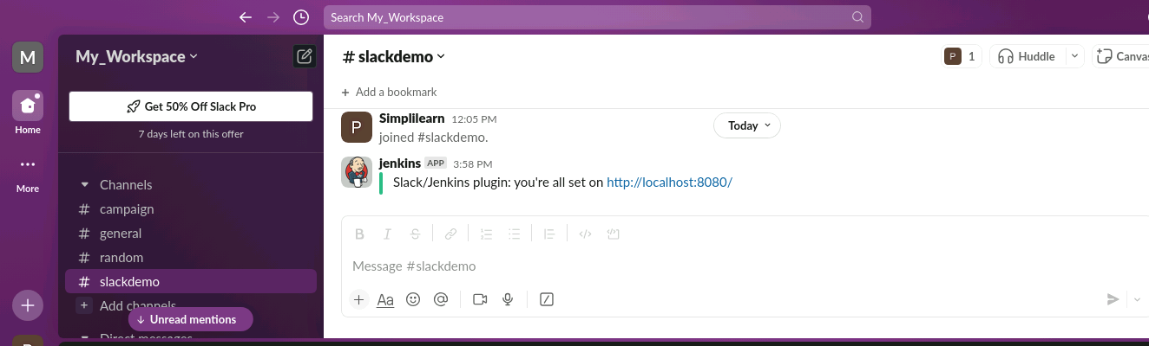
4. Check your mail inbox for the notification as shown in the screenshot below:

By following these steps, you have successfully set up Slack channel for configuring build notifications for receiving updates about the build process.